Client / Owner: | Ridley College
Contractor: | Roberston Restoration
Project Materials observed onsite: |  | Titanium UDL 30 Synthetic Roofing Underlayment by Owens Corning, Lastobond Shield HT by Soprema, Pre-punched, Unfading Black, 7mm thick, 16x12, 6x10, 6x9, and 6x8 slates from North Country Slate

Pretium was on site to review the progression of work. Only items observed by the reviewer and reported herein have been reviewed. Other conditions may be present which were not apparent to the reviewer at the time of the visit. The following was observed / discussed:
OBSERVATIONS / COMMENTS
- General
  - Project Status: 67% complete
  - Original Estimated Project Completion Date: August 23, 2024 (weather permitting)
  - Projected Completion Date: Project will not be completed by Aug. 23. Ridley has advised that all scaffolding must be removed from the south and east faces by end of day Aug. 28 at the absolute latest.

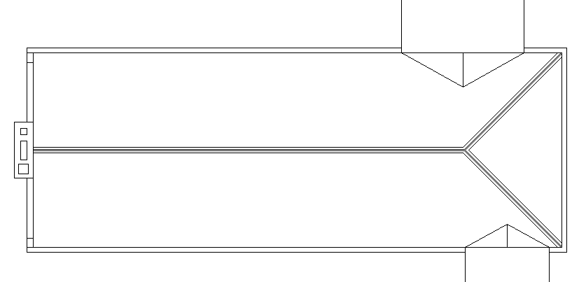
KEY PLAN
NOT IN CONTRACT
SCAFFOLDING IN PLACE
ACTIVE WORK AREA AT TIME OF VISIT
COMPLETE TO NEW UNDERLAYMENT
COMPLETE TO NEW SLATE



- Site / Staging Area
  - No changes in the staging area since Pretium’s previous visit were observed.
- Slate Roof
  - Robertson advised that all outstanding items on the east face will be completed by end of day today. Pretium requested that Roberston forward photos of all outstanding items once completed. Robertson agreed.
  - Roberston has begun removing plywood protection, wood planks, etc. from scaffolding on the south and east sides of the building and advised that a scaffolding crew will be onsite Monday (Aug. 26) to begin dismantling the scaffolding on the south and east sides of the building.
- Reglets at the southwest corner have been caulked. | 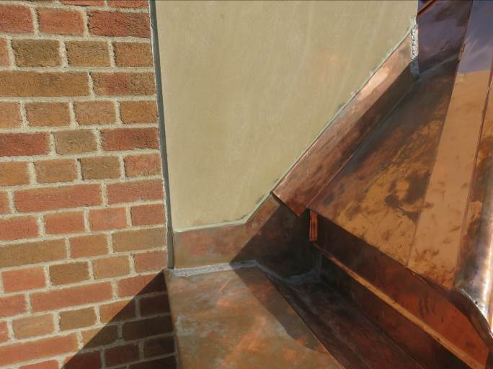
- New copper saddle and wall flashings at the southwest corner are not complete. Contractor advised this work will be completed form the west face once the copper saddle and slate in this area is complete | 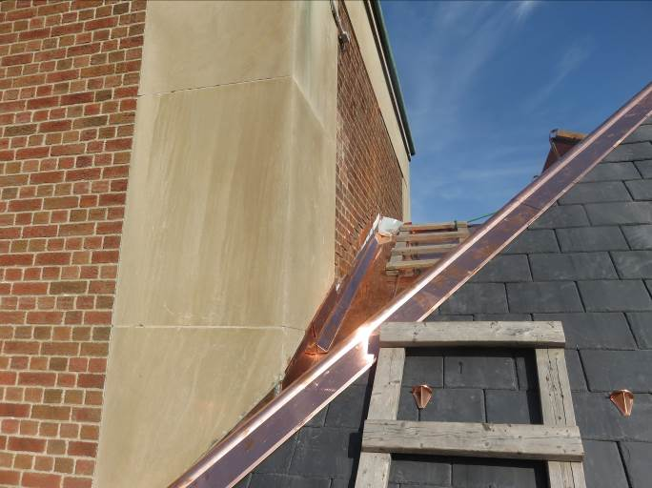
- New cooper saddle and wall flashings at the southeast corner are complete.  Reglet has not been caulked yet. Contractor advised this will be completed by end of day. | 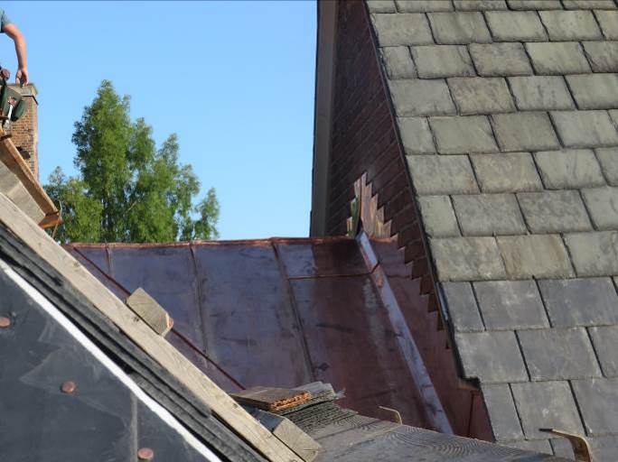
- Masonry repairs have been completed at the southern stub wall at the east face. | 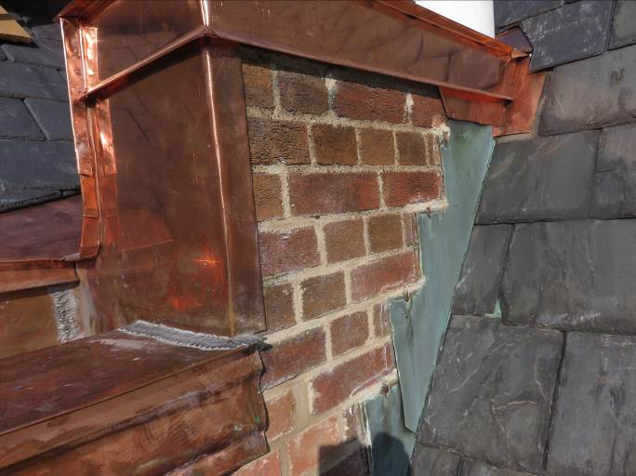
- Slate repairs have been completed at the south side of Gooderham House adjacent to stub wall. | 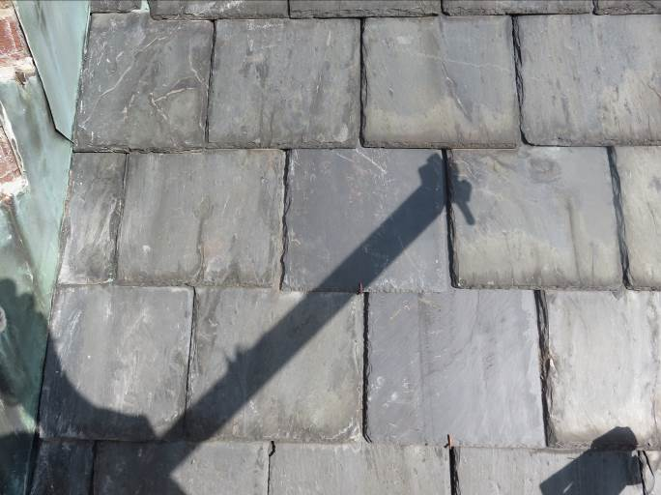
- Joints in stone gutter on south face have been cleaned and caulked. | 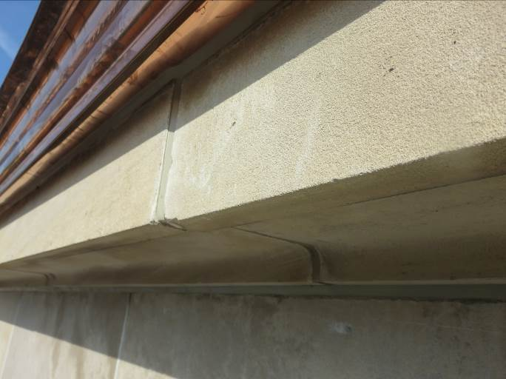
- Gutter at south face has been cleaned and is free of debris.  Partial removal of scaffolding and associated plywood protection has begun. | 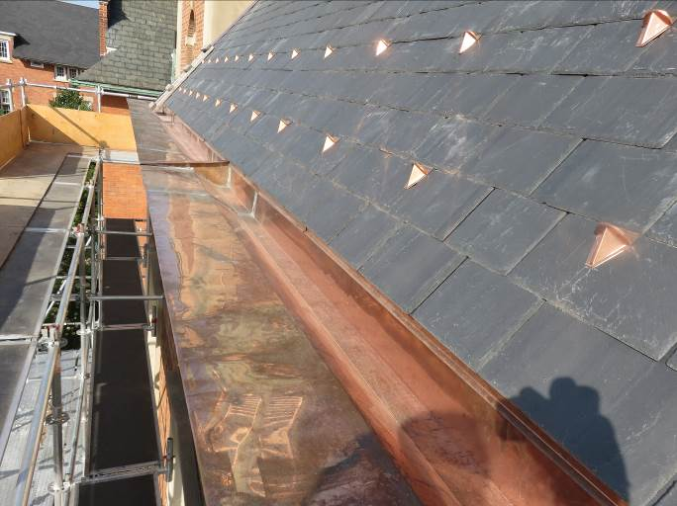
- New copper hip flashing has been installed at the southeast corner. Copper flashing has been secure with cooper cleats at approx. 12” O.C. | 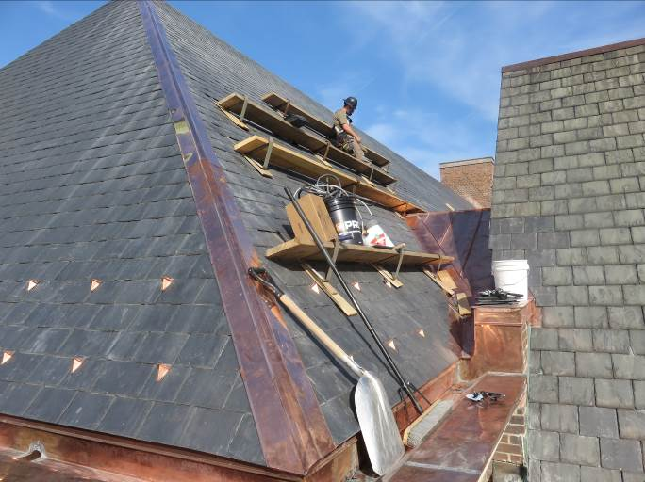
- New copper hip flashing has been installed at the bottom half of the southwest corner.  Contractor advised the upper half of the hip flashing will be completed from the western face once the slate in that area is complete. | 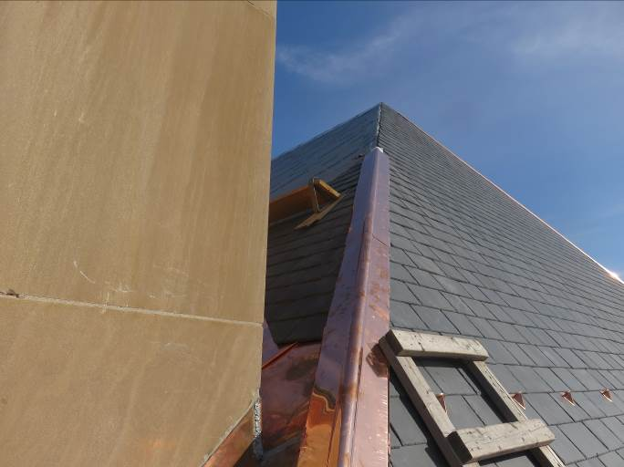
- Installation of slate on the east face is complete. Contractor was removing access planks and jacks, and repairing slates in these areas at time of visit. | 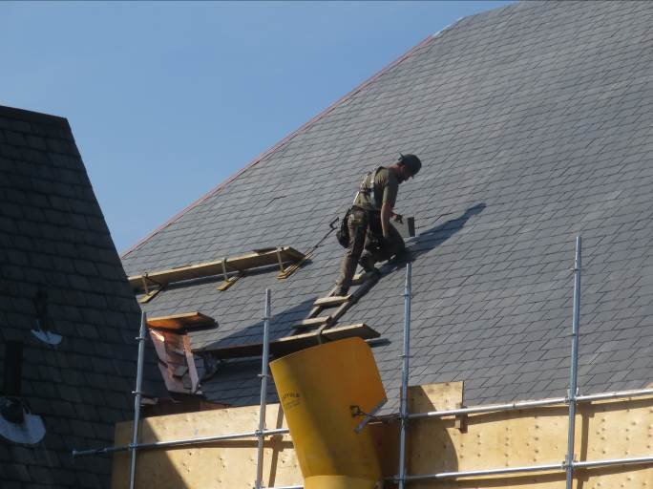
- Reglet at the parapet at the north end of the east face has not been caulked yet. Contractor advised this would be completed by end of day. | 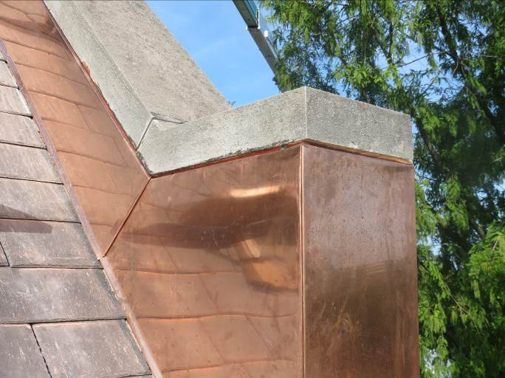
- New copper downspout has been installed at the northern outlet on the east face.  New copper downspout for the southern outlet has been fabricated but is yet to be installed. | 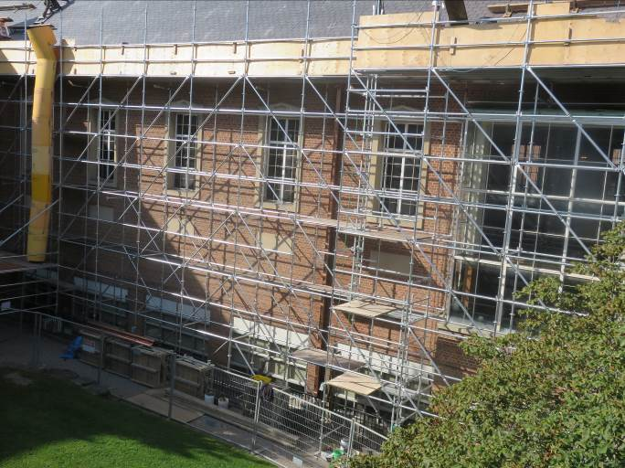  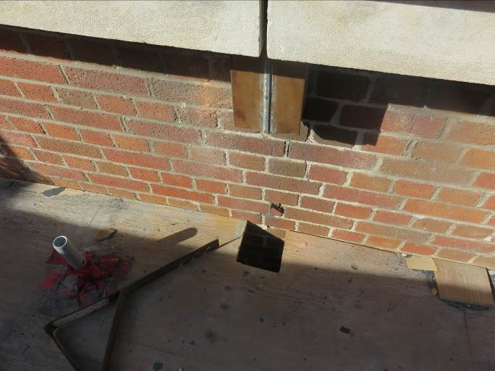  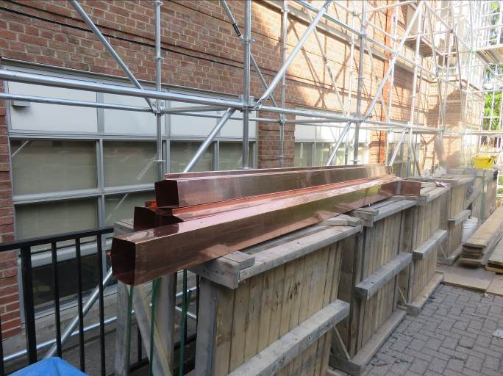
- All previously observed broken slates on the east face have been repaired.  Gutter on the east face has been cleaned and is free of debris. | 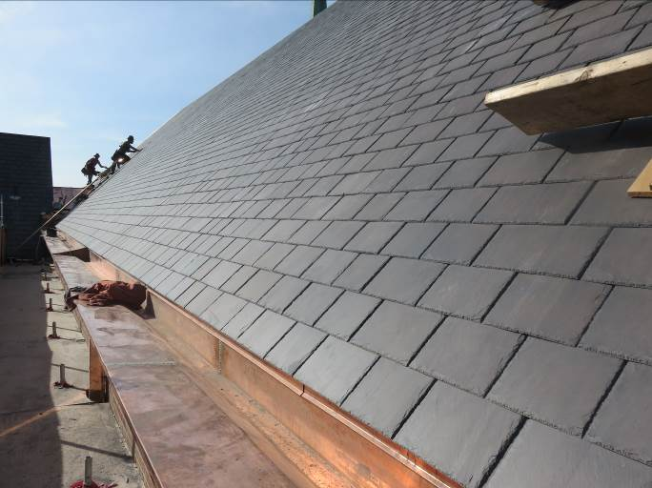
- Contractor to ensure slate dust, scraps, and all other debris are removed from the gutter prior to demobilizing. | 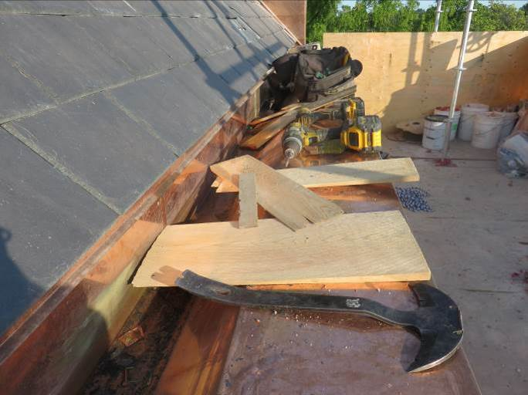
- Existing sealant has been removed from joints in stone gutter on east face. Joints have not been sealed yet. Contractor advised this would be completed by end of day.  Existing sealant at gutter joints on the east face was previously determined to not need replacement. Robertson to replace sealant at no additional expense. | 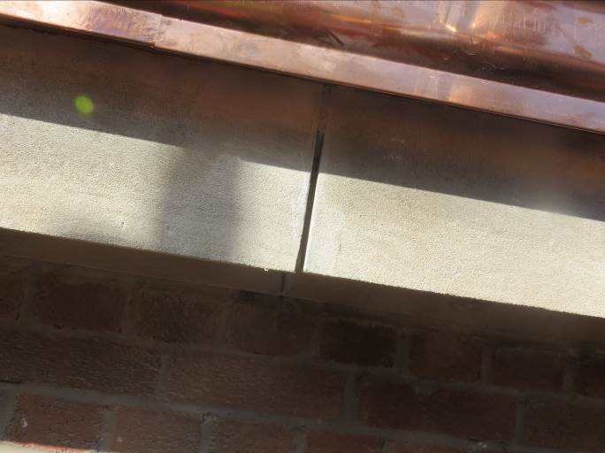
- Masonry repairs were in progress at the east side of the chimney at time of visit. Contractor advised that masonry repairs at the chimney would be complete by end of the day.  Contractor advised that the new copper flashing at the top of the chimney would be installed early next week. | 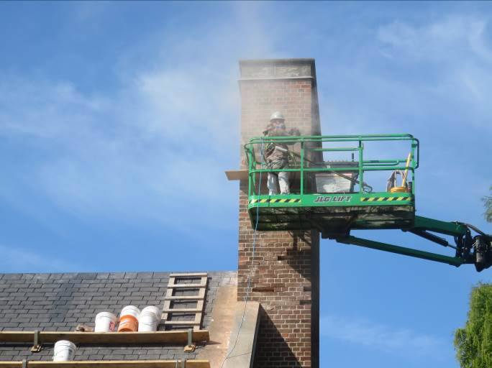

This report was issued to all parties on November 7, 2026.
Trade foreman was verbally notified of report contents. This report pertains to work specifically requested and comments only on operations and items that were visible or being undertaken at the time of our inspection.
Report by: | Dave Neal. H.Dipl.T., RRO

